1. **Morphological operations based on OpenCV using Closing technique.**

**Aim:**

To perform operations based on opencv using closure technique.

**Code:**

**import cv2**

**import numpy as np**

**img = cv2.imread(r"C:\Users\ADMIN\Pictures\images (1).jfif", cv2.IMREAD_GRAYSCALE)**

**kernel = np.ones((5,5), np.uint8)**

**closing = cv2.morphologyEx(img, cv2.MORPH_CLOSE, kernel)**

**cv2.imshow("Original", img)**

**cv2.imshow("Closing", closing)**

**cv2.waitKey(0)**

**cv2.destroyAllWindows()**

**Input:**

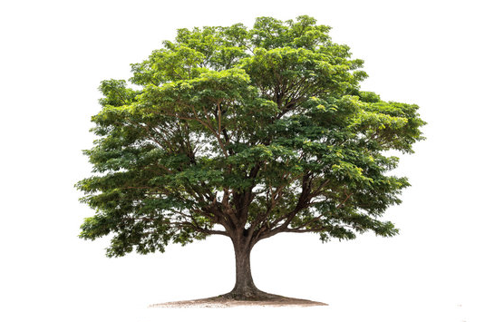

**Output:**

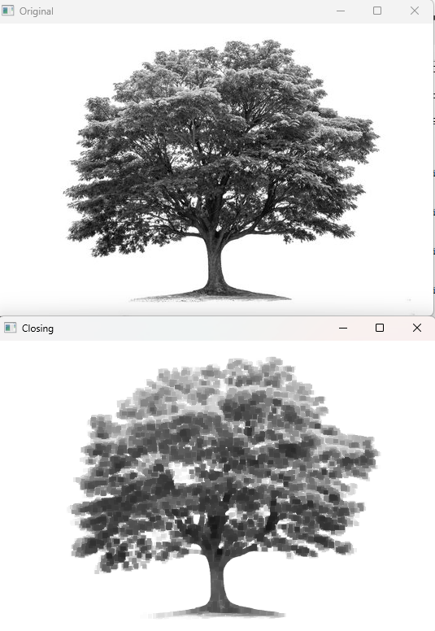

**Result:**

The python code to perform operations based on opencv using closure technique has been executed successfully.